Exploring Gao et al. as a method for finding the effective number of independent tests in metabolomic data

Valentinas Sungaila
When studying metabolomics data, thousands of tests can be run on the same dataset, which creates the multiple testing problem. Two popular methods that adjust for multiple testing are: Bonferroni’s correction and False Discovery Rate (FDR). The Bonferroni method can be quite conservative if there is correlation in a dataset, which could lead to a higher rate of false negatives. Instead, an effective number of independent tests can be estimated using a method by Gao et al. and applied with Bonferroni’s correction to help make the correction less conservative. In this paper, I first simulated data to evaluate how well Gao’s method performs at finding the effective number of independent tests for datasets with different pairwise correlation structures. The simulation results suggest that if a dataset has more predictors than observations then the effective number of independent tests will be underestimated. Second, I applied Gao’s method to a case study with 4817 metabolites and 40 observations estimating 39 effective independent tests. This is further evidence that Gao’s method underestimates the effective number of independent tests when the number of predictors is greater than the number of observations in a dataset. Overall, I uncover that Gao’s method performs well at finding the effective number of independent tests when the number of observations is much greater than the number of predictors being studied. But the method fails when the correlation in the dataset is small and the number of observations is not considerably larger than the number of predictors.
Introduction
Multiple testing is a problem that occurs when many separate hypothesis tests are performed on the same sample. When multiple tests are run, the p-values need to be adjusted for the number of hypothesis tests to control the overall Type I error rate (incorrectly rejecting the null hypothesis). As more tests are run, the chance of at least one false positive result increases with every additional test. Under the null hypothesis of no association for each test, given 10,000 independent tests on the same sample, the expected number of incorrect rejections (known as false positives or Type I errors) is 500 if a standard alpha level of 5% is used.
A way to correct for multiple testing is to use the Bonferroni correction¹. Bonferroni correction controls the family-wise error rate (FWER) also known as false positive rate (FPR) for at least one test, which means there is a probability of at least one Type I error when performing multiple tests. To correct for multiple testing, the Bonferroni method alters the p-value by multiplying each p-value by the number of tests. The adjusted p-value reduces the number of false positives but also reduces the number of true discoveries (Type-II errors).This occurs because as the number of tests increases, the p value with Bonferroni correction becomes larger and less likely to be below the significance threshold. This results in the null hypothesis not being rejected despite there being a true association. Another problem with the application of the Bonferroni correction is that it assumes that the tests are being performed on independent variables, which is usually not true. This therefore makes the Bonferroni correction a conservative method, because if the data has high correlation then the effective number of independent tests is much lower than what Bonferroni’s method assumes and uses to alter the p-value.
Another popular method that is an alternative to Bonferroni’s correction and is used to correct for the multiple testing problem is the False Discovery Rate¹ (FDR). Unlike Bonferroni which looks at FPR, the probability of rejecting a null hypothesis given that the null hypothesis is true, FDR is the probability that a null hypothesis is true given that the null hypothesis has been rejected. A drawback of FDR is when a dataset is highly correlated, FDR can also be conservative because classic FDR also assumes that tests are independent from one another. Meaning that FDR makes it as hard as Bonferroni’s adjustment to find the first independent test. But, makes it easier to find subsequent tests after.
New methods have been created that help Bonferroni correction to be less conservative. These methods first estimate the effective number of independent tests ($M_{effs}$) in a sample and use this value in the Bonferroni correction. These methods include Gao et al.², Li and Ji³, and Cheverud⁴, and Nyholt⁵. These methods have been used in genomic data such as with testing for single nucleotide variants in gene regions and testing for methylation⁶. Hendricks et al. find that the Gao et al. method is an efficient approach to control for multiple testing in gene regions over other methods because the method produces Type-I error rates closest to the chosen significance level compared to other methods⁷.
One field of study where multiple testing has become a problem is metabolomics. In recent years, high-throughput technologies have enabled thousands of metabolites in one research study. When actions such as hypothesis testing is performed on each metabolite separately, multiple testing becomes a problem because of the high number of tests needed to run. Also, metabolomics data can have different correlation structures which can lead the Bonferroni method to be overly conservative if a high correlation is present among observations or variables. Thus, leading to more Type-II errors as the number of tests performed increases.
This paper will evaluate the effectiveness of the Gao et al. method (referred throughout the paper as Gao’s method) for use in adjusting for multiple testing in metabolomic studies using both simulated data and a case study with 4817 metabolites and 40 observations to estimate the effective number of independent tests. Also, explore Gao’s method and describe where the method does and does not perform well.
Methods
Gao’s Method
Gao’s method, first introduced in a 2008 paper by Gao et al., is a fast and more accurate alternative for dealing with multiple testing in single nucleotide polymorphisms (SNP’s)². Gao’s method finds the effective number of independent tests ($M_{eff}$) in the data using principal component analysis (PCA). PCA is a statistical approach that transforms a set of likely correlated variables into a set of linearly independent variables which are called principal components. This is useful because the information distributed is transformed into PC’s such that when the PC’s are ordered in terms of how much variation they capture in the original space, the first few PC’s can sometimes explain a sizeable chunk of the total variance.
To find the PCs, eigenvalue decomposition is performed using the pair-wise metabolite correlation matrix. Each eigenvalue can be interpreted as the amount of variance explained by the corresponding principal component. The effective number of independent variables, $M_{eff}$, is derived using the equation below.
$$\frac{\sum_{m=1}^{M_{eff}}{λ_{m}}}{\sum_{m=1}^{M}{λ_{m}}} ≥c$$

where M represents the total number of metabolites in the data. $λ_{m}$ are the eigen values for each principal component m.
To calculate the effective number of independent tests, Gao’s method takes the first eigenvalue and divides it by the total sum of all the eigenvalues. If the proportion is less than C, then the next biggest eigenvalue is added to the numerator and the process is repeated. If the summed proportion is greater than or equal to some threshold C, then the number of eigenvalues summed in the numerator is the total number of eigenvalues needed to explain certain proportion of the data space. Using different thresholds, i.e. C, alters the $M_{eff}$ value needed, with C closer to 1 typically needing more $M_{eff}$and a smaller C needing less $M_{eff}$. Gao et al. recommends the threshold of .995 which will be used here.
Simulations
Since metabolites can be correlated, data was simulated to observe how well Gao’s method performs under different pairwise correlation structures. Different numbers of predictors (p) and observations (N) were sampled from a multivariate normal distribution with mean zero and sigma p*p matrix of chosen correlation for each simulation scenario. Statistical software R version 1.2.1335 and the mvrnorm function form the MASS package was used to find the pairwise correlation matrices with five different correlation values 1, 0.8, 0.5, 0.2, and 0 that were constant over the whole simulated matrix. Using the eigen function from the same statistical software, eigenvalues were found for each simulated sample. Then Gao’s method was applied to find the $M_{eff}$ for each simulation scenario. Each simulation was repeated ten times to account for sampling variability and to make sure that Gao’s method estimated the same number of independent tests each time.

Table 1. Simulation Parameters
Pairwise correlations for simulated matrices | 1, 0.8, 0.5, 0.2, 0
Number of predictors (p) | 10, 20, 100, 200, 1000, 4000
Number of observations (N) | 10, 100, 1000, 10000

To check how well Gao’s method performs with large datasets and to check if the method can estimate already known effective number of independent tests, perfectly correlated blocks of different sizes were generated. For this simulation scenario, a matrix is created from a multivariate normal distribution with mean zero and sigma p*p matrix of perfect correlation (correlation = 1) and is made up of a chosen number of blocks 2,3,5, and 10. Therefore, the effective number of independent tests for each block is always 1. Thus, the effective number of independent tests for the created matrix should be the number of blocks in the matrix. Because of length of computations, each simulation was run 10 times to see if there is any variation in Gao’s method at estimating the effective number of independent tests.

Table 2. Block Simulation Parameters
Number of blocks (B) | 2, 3, 5, 10
Number of predictors in each block (Pb) | 10, 100, 1000
Number of observations (Nb) | 100, 1000

Figure 1. Perfectly correlated block matrix example
1 | 1 | 0 | 0
1 | 1 | 0 | 0
0 | 0 | 1 | 1
0 | 0 | 1 | 1
Above is a matrix made up of two 2x2 perfectly correlated blocks which would have 2 independent tests.
Case Study
For the case study the research dataset has 40 observations with 4817 different metabolites. The data comes from the O’Connor et al. study⁸ where people were fed a Mediterranean diet and their blood samples were drawn. The metabolites present for each person (observation) in the dataset are from the baseline, meaning that these metabolites come from people’s diets before they started to consume a Mediterranean diet. The data was transformed log base 2 by the data collectors. Before Gao’s method can be applied, the metabolites are standardized by subtracting the mean and dividing by the standard deviation of each metabolite, which allows for them to be compared on the same scale. Then the pairwise covariance matrix for the metabolites is estimated. Gao’s method is used to estimate the effective number of metabolites.
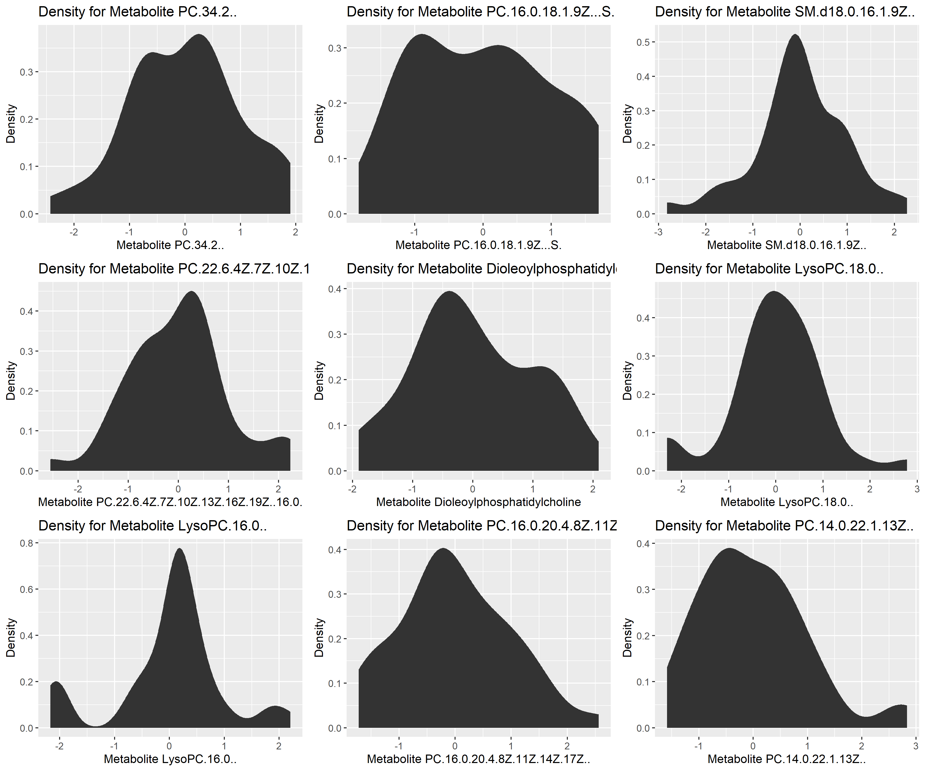
Figure 2. Metabolite distributions
Densities for the first nine metabolites in the data. Looking at the densities of all 4817 metabolites is too computationally expensive. The densities were created using R statistical software version 1.2.1335 with the ggplot function from ggpolt2 package.
As can be seen in the figure above each metabolite has its own unique density. Meaning, that some more transformations of the metabolites may be necessary. This also shows that using multivariate normal distribution for the simulation is somewhat appropriate because a few of the metabolites have densities that resemble a bell curve and thus my simulations are somewhat an appropriate representation of the metabolites data.
Results
Simulations
Starting with the extreme Pearson’s correlations (corr) of 1 and 0, Table 3 shows the effective number of independent tests when Gao’s method is applied for different number of observations (N) and different number of predictors (p). When correlation is 1, irrespective of the amount of observations or predictors, Gao’s method estimates 1 independent test. When correlation is 0, the estimated number of independent tests by Gao’s method appears to depend on and be limited by the number of predictors or the number of observations. Also, when the number of observations is much bigger (e.g. N = 10000 > p = 100) than the number of predictors then the expected number of independent tests is reached. But, when p = 1000 or p = 4000, having N = 10000 is not enough to reach the expected number of independent tests.

Table 3. Mean effective number of tests (Range) for pairwise Corr = 0 and 1
 | p = 10 |  | p = 100 |  | p = 1000 |  | p = 4000
 | Corr = 0 | Corr = 1 | Corr = 0 | Corr = 1 | Corr = 0 | Corr = 1 | Corr = 0 | Corr = 1
N = 10 | 8.1  (7,9) | 1  (1,1) | 9  (9,9) | 1  (1,1) | 9  (9,9) | 1  (1,1) | 9  (9,9) | 1  (1,1)
N = 100 | 10  (10,10) | 1  (1,1) | 81.8  (81,83) | 1  (1,1) | 98.1  (98,99) | 1  (1,1) | 99  (99,99) | 1  (1,1)
N = 1000 | 10  (10,10) | 1  (1,1) | 99.2  (99,100) | 1  (1,1) | 817.7  (817,817) | 1  (1,1) | 981  (981,981) | 1  (1,1)
N = 10000 | 10  (10,10) | 1  (1,1) | 100  (100,100) | 1  (1,1) | 990  (990,990) | 1  (1,1) | 3879.2  (3879,3880) | 1  (1,1)
This table shows the mean of the effective number of independent tests estimated by Gao’s method when simulated 10 times, sampled from a multivariate normal distribution. Range is reported in the parenthesis with minimum value on the left and the maximum value on the right. N represents the number of observations in the simulation. P represents the number of predictors in the simulation.

Under mild, moderate, and strong correlation, the effective number of independent tests increases as the number of predictors increases. When N = p or N < p the effective number of independent tests is approaches the number of observations N as shown in Table 4.
Table 4. Mean effective number of tests (Range) for N = 100 as p and Corr change
 | N = 100
 | Corr = 0.2 | Corr = 0.5 | Corr = 0.8
p = 10 | 10  (10,10) | 10  (10,10) | 10  (10,10)
p = 20 | 20  (20,20) | 20  (20,20) | 19  (19,20)
p = 100 | 80  (79,81) | 76.7  (76,78) | 70.1  (68,72)
p = 200 | 94.6  (94,95) | 92.2  (91,93) | 85.5  (83,87)
p = 1000 | 98  (98,98) | 97.6  (97,98) | 94.2  (94,95)
p = 4000 | 99  (99,99) | 98  (98.98) | 95.9  (95,97)
This table shows the mean of the effective number of independent tests estimated by Gao’s method when simulated 10 times, sampled from a multivariate normal distribution. Range is reported in the parenthesis with minimum value on the left and the maximum value on the right. N represents the number of observations in the simulation. P represents the number of predictors in the simulation.

For mild, moderate, and strong correlation, the effective number of independent tests increases as the number of observations increases until it approaches, but never reaches 100, which is the number of predictors in the sample which is expected because there is correlation present in the data. Also, when N < p the effective number of independent tests seems to be limited by the number of observations N as shown in Table 5.
Table 5. Mean effective number of tests (Range) for p = 100 as N and Corr change
 | p = 100
 | Corr = 0.2 | Corr = 0.5 | Corr = 0.8
N = 10 | 9  (9,9) | 9  (9,9) | 9  (9,9)
N = 20 | 19  (19,19) | 19  (19,19) | 18.1  (18,19)
N = 100 | 80  (79,81) | 76.7  (76,78) | 70.1  (68,72)
N = 200 | 95.2  (95,96) | 93  (92,94) | 86.7  (84,88)
N = 1000 | 99  (99,99) | 98.3  (98,99) | 95.8  (95,96)
This table shows the mean of the effective number of independent tests estimated by Gao’s method when simulated 10 times, sampled from a multivariate normal distribution. Range is reported in the parenthesis with minimum value on the left and the maximum value on the right. N represents the number of observations in the simulation. P represents the number of predictors in the simulation.

The effective number of independent tests increases as the number of observations increases but the number of independent tests is still limited by the number of observations in each sample for each iteration as shown in Table 6.
Table 6. Mean effective number of tests (Range) for p = 100 as N and Corr change
 | p = 4000
 | Corr = 0.2 | Corr = 0.5 | Corr = 0.8
N = 10 | 9  (9,9) | 9  (9,9) | 9  (9,9)
N = 20 | 19  (19,19) | 19  (19,19) | 19  (19,19)
N = 100 | 99  (99,99) | 98  (98,98) | 95.9  (95,97)
N = 200 | 197.3  (197,198) | 196  (196,196) | 191.7  (191,193)
N = 1000 | 977.1  (977,978) | 965  (964,966) | 921.7  (919,925)
This table shows the mean of the effective number of independent tests estimated by Gao’s method when simulated 10 times, sampled from a multivariate normal distribution. Range is reported in the parenthesis with minimum value on the left and the maximum value on the right. N represents the number of observations in the simulation. P represents the number of predictors in the simulation.
Table 7 shows the estimated effective number of independent tests for each block with different number of observations (Nb) and different number of predictors (Pb) when Gao’s method is used. The effective number of independent tests equals the number of blocks for each simulation regardless of the number of observations and number of predictors.

Table 7. Mean effective number of tests (Range) in block simulation
 | B = 2 |  | B = 3 |  | B = 5 |  | B = 10
 | Nb = 100 | Nb = 1000 | Nb = 100 | Nb = 1000 | Nb = 100 | Nb = 1000 | Nb = 100 | Nb = 1000
Pb = 10 | 2  (2,2) | 2  (2,2) | 3  (3,3) | 3  (3,3) | 5  (5,5) | 5  (5,5) | 10  (10,10) | 10  (10,10)
Pb = 100 | 2  (2,2) | 2  (2,2) | 3  (3,3) | 3  (3,3) | 5  (5,5) | 5  (5,5) | 10  (10,10) | 10  (10,10)
Pb = 1000 | 2  (2,2) | 2  (2,2) | 3  (3,3) | 3  (3,3) | 5  (5,5) | 5  (5,5) | 10  (10,10) | 10  (10,10)
This table shows the effective number of independent tests estimated by Gao’s method from block simulations sampled from a multivariate normal distribution. Each block has a perfect correlation of 1. Range is reported in the parenthesis with minimum value on the left and the maximum value on the right. B represents the number of blocks in the simulation. Nb represents the number of observations in each block in the simulation. Pb represents the number of predictors in the simulation.

Case Study
To check for pairwise correlation in the case study metabolite data, a heatmap is shown in Figure 3. When food is broken down into metabolites, some of the metabolites are also broken down into pieces that can be shown as a different metabolite. Therefore, it is expected that some correlation should be present in metabolites data when all the metabolites are compared together.
Figure 3. Correlation heatmap for 4817 metabolites.
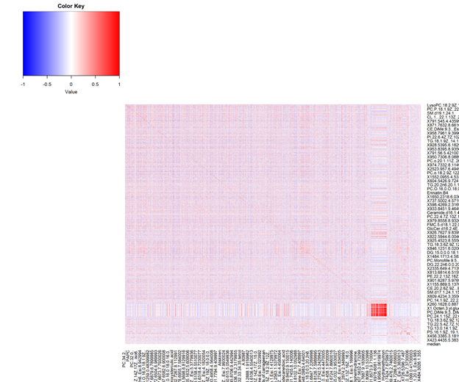
The heatmap was generated using statistical software R version 1.2.1335. Using the hearmap.2 function from the gplots package.

There is one square on the heatmap that shows high correlation among some of the metabolites. Overall, the heatmap suggests that there is not a high degree of correlation between metabolites in the data. Referring to table 6 for corr = 0.2 the simulation for p =100 and N = 20 suggests 19 independent tests and for p =100 and N = 100 suggest 99 independent tests, meaning that Gao’s method should estimate somewhere between those two values. The effective number of independent tests estimated by Gao’s method is 39. Meaning that when adjusting for multiple testing using Bonferroni’s adjustment Gao’s method suggests the use of 39 tests for the adjustment.

Discussion
When looking at the simulation when the pairwise correlation equaled one, Gao’s method estimated one effectively independent test. This is expected and correct because if all variables are perfectly correlated with one another, then only one test is needed to explain the whole data space. However, when the pairwise correlation between the variables is zero, two situations happen: Gao’s method either estimates the appropriate number of independent tests or it underestimates the effective number of independent tests. When looking at all independent predictors in the dataset, Gao’s method estimates the appropriate number of independent tests when the number of observations is much greater than the number of predictors or the correlation structure is high among the predictors as in the block simulation. Gao’s method underestimates the effective number of independent tests when the number of observations is not much larger than the number of independent predictors. As the number of independent predictors increases, the effective number of independent tests should also increase.
Given independent predictors where we expect $M_{eff}$ to equal p, the biggest factor that seems to drive $M_{effs}$ for Gao’s method is how many predictors and observations are present in the data.
- When N > P then $M_{eff}$ is often slightly underestimated
- When N ≤ P Gao’s estimate of $M_{effs}$ will be less than or almost equal to N
These results suggest that if a dataset has more independent predictors than observations and uses Gao’s method to estimate the $M_{effs}$, then the $M_{effs}$ will be underestimated because $M_{effs}$ will be limited by the sample size if the pairwise correlation among data is very small.
When looking at blocks with perfect correlation where $M_{eff}$ is equal to the number of blocks irrespective of the number of observations or number of predictors in the model, Gao’s method did well at estimating the correct $M_{eff}$. Proclaiming that Gao’s method performs well when the correlation is very high among the predictors.
For the case study, Gao’s method estimates 39 effectively independent tests out of 4817 metabolites. This result is consistent with the results observed in the simulated data for 40 observations. Signifying that the pairwise correlation among the metabolites is small with many independent tests thus the result is likely driven by the small number of observations not the true effective number of independent metabolites. Concluding that, Gao’s method should not be used for metabolomics data because of the low pairwise correlation among the metabolites. Unlike Bonferroni’s adjustment with Gao’s estimate of independent tests, false positive rate would likely work better for the metabolites data since FDR would not be conservative given the low correlation of metabolites.
Overall, Gao’s method performed differently than expected. The result appears to be mostly driven by the correlation of the data when Gao’s method estimates the number of independent tests. In simulated data with N less than or equal to p, the the number of $M_{effs}$ would be very close to N as correlation decreases. This was also shown in the case study where the metabolites did not have a correlation as big as first expected and Gao’s method estimated $M_{effs}$ of 39 for the case study, which is close to the sample size. But the block simulation showed that when correlation among the predictors is high, no matter the sample size, or the number of predictors, Gao’s method estimated the expected $M_{eff}$. Thus, a flaw in Gao’s method is exposed. If the sample size is much smaller than the number of predictors and there is not much correlation, then $M_{effs}$ estimate will be close to the sample size. In addition, when the sample size is larger than the number of predictors and there is not much correlation, then Gao’s method will underestimate the $M_{eff}$ unless the number of observations is much greater than the number of predictors. Which leads me to conclude that the limiting factor for the number of independent tests in Gao’s method is the rank of the matrix.
In future studies it would be interesting to see another method besides Gao being applied to the metabolite dataset because most likely the $M_{effs}$ would be different. Another way to modify Gao’s method is to explore the threshold value C. Perhaps the threshold would need to be altered depending on the sample size, the number of predictors, and how correlated the predictors are with each other. Therefore, it can be concluded that Gao’s method is flawed at estimating the effective number of independent tests when the correlation in a dataset is small or the sample size is smaller than the number of independent predictors.

Works Cited
1 Goldman M: Why is multiple testing a problem? Department of Statistics UC Berkeley 2008 https://www.stat.berkeley.edu/~mgoldman/Section0402.pdf.
2 Gao X, Starmer J, Martin ER: A multiple testing correction method for genetic association studies using correlated single nucleotide polymorphisms. Genet Epidemiol 2008; 32: 361–369.
3 Li J, Ji L: Adjusting multiple testing in multilocus analyses using the eigenvalues of a correlation matrix. Heredity 2005; 95: 221–227.
4 Cheverud JM: A simple correction for multiple comparisons in interval mapping genome scans. Heredity 2001; 87: 52–58.
5 Nyholt DR: A simple correction for multiple testing for single-nucleotide polymorphisms in linkage disequilibrium with each other. Am J Hum Genet 2004; 74: 765–769.
6 Zhou Z, Lunetta KL, Smith AK, et al. Correction for multiple testing in candidate-gene methylation studies. Epigenomics. 2019 Jul;11(9):1089-1105. DOI: 10.2217/epi-2018-0204.
7 Hendricks, A., Dupuis, J., Logue, M. et al. Correction for multiple testing in a gene region. Eur J Hum Genet 22, 414–418 (2014). https://doi.org/10.1038/ejhg.2013.144
8 O’Connor, L.E.; Li, J.; Sayer, R.D.; Hennessy, J.E.; Campbell, W.W. Short-Term Effects of Healthy Eating Pattern Cycling on Cardiovascular Disease Risk Factors: Pooled Results from Two Randomized Controlled Trials. Nutrients 2018, 10, 1725.

